

Fixing bugs

AA03

Juni 2020

# 

# 

# Index

**Index** **1**

**Introduction** **1**

**Check-box column will be first column in address grid** **2**

Description 2

Solution 2

**By default, all check-box will be checked** **3**

Description 3

**Rename ‘zoom’ to apply** **4**

Description 4

Solution 4

**Place button ‘reload’** **5**

Description 5

# 

# Introduction

This bugfix report contains information about the bugs I solved in the project AA03.

This document describes what the bug entailed with a short description and photos. Then it is described how I solved the bugs with a code block.

I have had to look up 4 bugs and fix all 4 in the AA03 application. The application is made in c # and uses leaflet.

# 

# 

# Check-box column will be first column in address grid

## 

## Description

The address text is placed first then the checkbox is placed. The issue is that the checkbox needs to be placed first. So when you activate the dropdown the checkboxes will be on the left and the addresses will be next to the checkboxes.

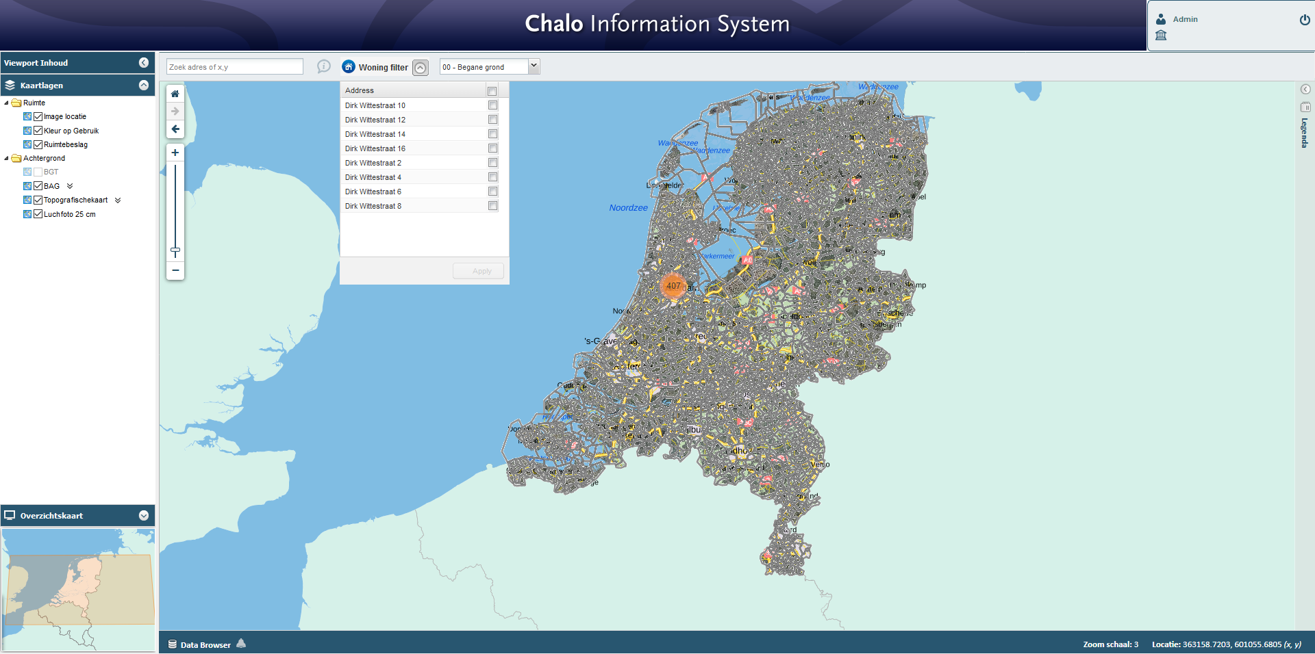

## Solution

First load checkboxes. After that load the address text. That way the checkboxes will be placed before the address text.

# 

# 

# By default, all check-box will be checked

## Description

The dropdown shows checkboxes. The issue is that the checkboxes are not selected by default. The intention is that all checkboxes are selected by default so user only needs to press ‘apply’.  


## Solution

Find the function that triggers the checkboxes and make it trigger by default.

# 

# 

# Rename ‘zoom’ to apply

## Description

The issue is that the button ‘zoom’ needs a different name. The name is unclear and weird right now. The button name will be changed to ‘apply’

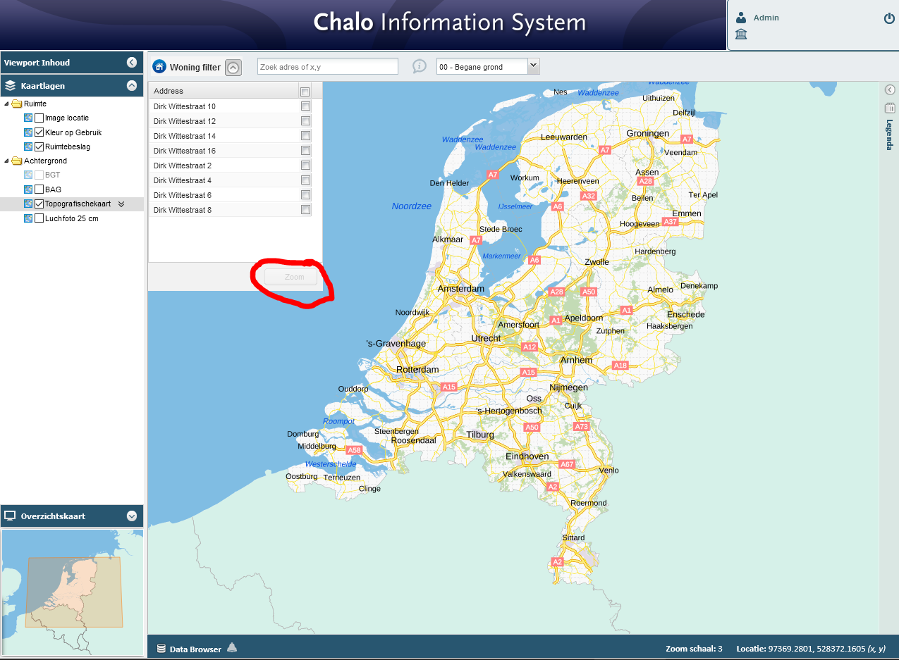

## Solution

The name ‘zoom’ is given inside the scripts/script.js file. Simply replace the text ‘zoom’ with ‘apply’.

# 

# 

# Place button ‘reload’

## Description

The issue is that there is no ‘reload’ button inside the address dropdown. The ‘reload’ button will be located before the ‘apply’ button.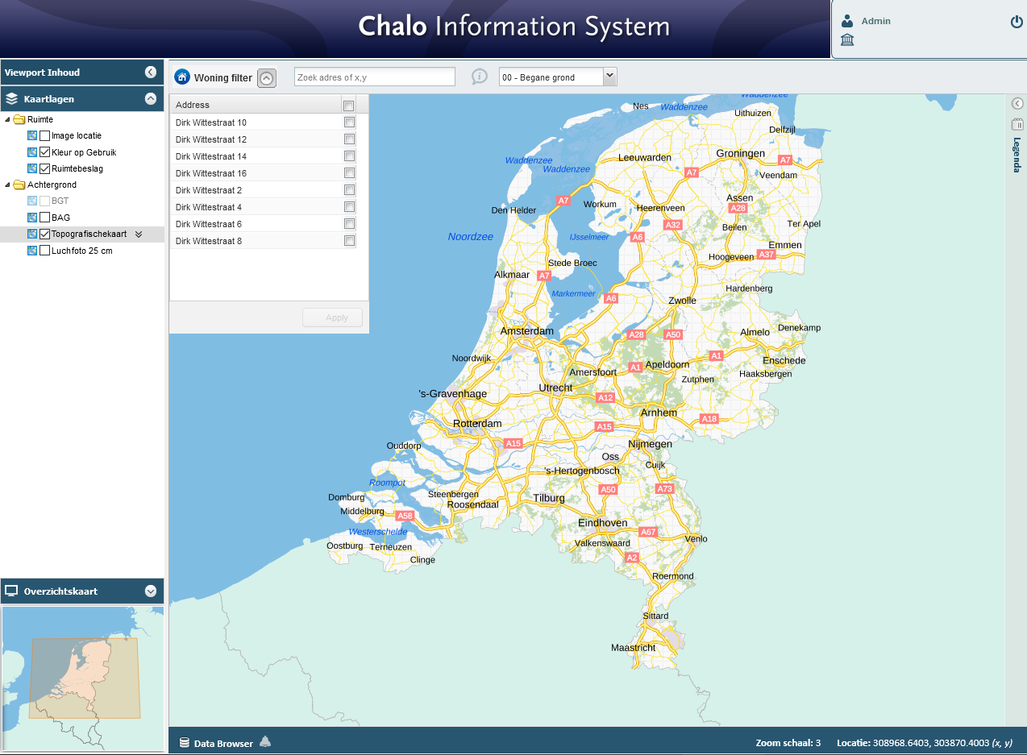

## 

## Solution

Add a reload button next to the apply button.